Scenario-

Try scenario when user enters wrong username and password should not be able to login.

User should see error message.

In this case user is not getting error message, please report a bug for this.

1. Please follow the below template to report a bug.
2. Report a bug into jira and assign it me.

<https://www.saucedemo.com>

Bug Reporting Template

Summary- when user enters wrong username and password. User is not getting any error message. Bug title should be one liner, short and clear.

Steps to reproduce-

Always start with page url.

1. Open the SWAGLABS page.
2. Enter any username.
3. Enter the given password.
4. Click on the login button.
5. **See the attached logs for more information**.

Actual Result- After entering log in button user getting “Epic sadface:

Username And Password do not match any user in this service”

this message.

Expected Result-After entering log in button should be promoted error message.

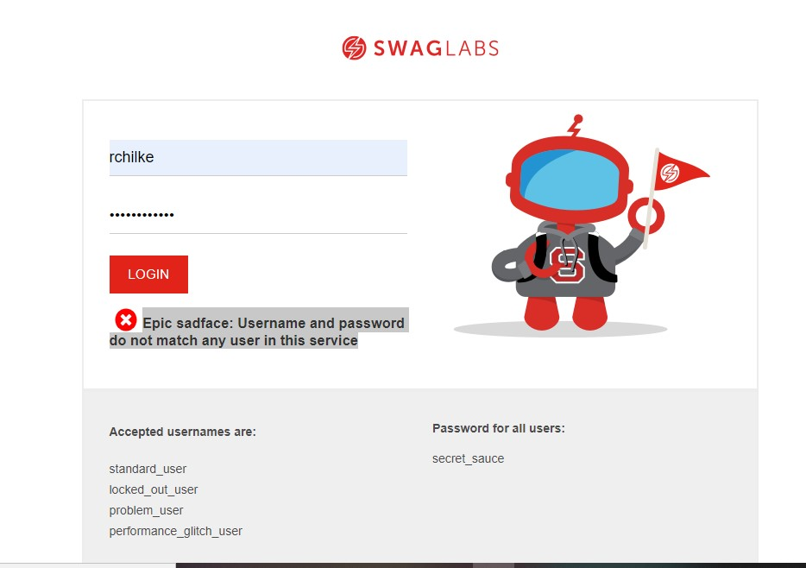Screenshot/Video-

* Bug steps/details should be written in a such way that given the reader clear direction as to what steps to performed.
* Use steps wording as if you are telling someone do this, do that….so on.
* Steps should always start with verb.

Also refer below links for bug steps writing tips-

1. <https://medium.com/we-are-testers/chapter-4-how-to-write-clear-and-efficient-steps-to-reproduce-in-your-bug-report-d96039a1c77d>
2. <https://docs.moodle.org/310/en/How_to_add_steps_to_reproduce_to_a_bug_report>

Please refer the below sample bug template which i have written for your understanding.

Sample template-

Bug Title/Summary: Error message is not shown to user upon entering wrong username or password

Steps to reproduce-

1. Launch URL <https://www.saucedemo.com> in browser
2. SWAGLABS login page will be displayed
3. Now enter any usernames other than the provided on login page (e.g. testuser)
4. Enter the password (secret_sauce)
5. Click login button

Actual Result- User is not seeing any error message for entering wrong username.

Expected Result- After entering log in button user should see error message that reads “Epic sadface: Username And Password do not match any user in this service”

Please refer to attached screenshot for your reference.

